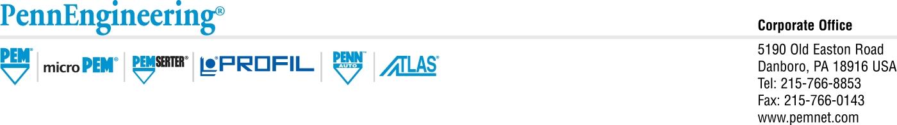

January, 2022

RE: REACH 223 SVHCs

The latest list for REACH SVHCs (as noted below); specifically the 4 additions, are not present in any product manufactured and supplied by PennEngineering. We are currently contacting packaging and plastic components manufacturers (panel assemblies) and should have this feedback in the next 15 business days.

After review of all plastics and packaging suppliers and their responses PennEngineering finds no changes to SVHCs from the 219 list. There are no new suspect or materials on concern at this time.



At this time we find no issue with the use of our standard products in relation to REACH 223 outside of our previously communicated limitations under REACH SVHC 219. The statement of compliance for PennEngineering products can be found on our website, [www.pemnet.com](http://www.pemnet.com) under the Sustainability tab.

Respectfully,

Rocky Pinheiro, PhD.

Global Vice President of Quality, PennEngineering

[rpinheiro@pemnet.com](mailto:rpinheiro@pemnet.com), 586-610-3500