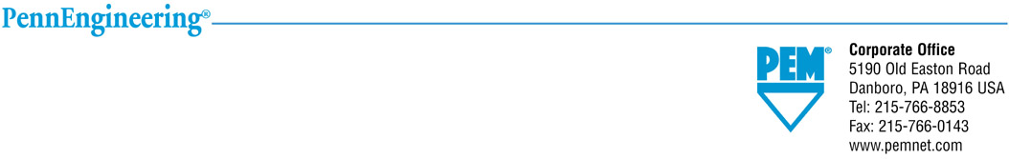
PennEngineering
Conflict Minerals - Policy

August 2019

PennEngineering is committed to social and environmental responsibility in our activities as well as within our supply chain. In addition to our commitment, we must meet regulatory obligations in addition to specific customer requirements when flowed down to us.

On August 22, 2012, the U.S. Securities and Exchange Commission released the rules for section 1502 of the Dodd-Frank Wall Street Reform and Consumer Protection Act. These rules require U.S. publically traded companies to trace the Tantalum, Tin, Tungsten and Gold in their products through the supply chain, and disclose whether they came from “conflict mines” in the Democratic Republic of the Congo (DRC). Although PennEngineering is not publically traded, our intention is to comply with these rules as a part of our community responsibility. We also want to be responsive to many of our customers that are publically traded.

The Electronics Industry Citizenship Coalition (EICC) and the Global e-Sustainability Initiative (GeSI) have created a Conflict Minerals Reporting Template as a common means to collect information on the source of Tantalum, Tin, Tungsten and Gold. This template is being widely used across the Electronics industry. The template, training materials, and additional information can be found at www.conflictfreesmelter.org .

PennEngineering is using this template for our internal due diligence activities and reporting to our customers. This template is available for customer review on the following link: PennEngineering_EICC template. PennEngineering conducted an exhaustive due diligence process which included the identification of materials or minerals of concern in our products, as well as the identification and communication with the applicable suppliers, which is now complete. Our template was updated using the Rev 5.12 EICC template with the latest supplier information in August 2019.

We are requiring the following from our suppliers, if any of the conflict minerals are intentionally added and are necessary to the functionality or production of any applicable product:
- A completed EICC-GeSI Conflict Minerals Reporting template.
- Provide a certification that the products supplied to PennEngineering that contain tantalum, tin, tungsten or gold did not originate from the Democratic Republic of the Congo or adjoining countries.
- Provide the names and pertinent information of the smelters they use.

PennEngineering will take the appropriate actions to comply with applicable rules in addition to supporting our customers to reach our common goal to build up a socially and environmentally responsible supply chain.
To request information or ask a question please E-mail – compliance@pemnet.com

