PennEngineering• Corporate Office

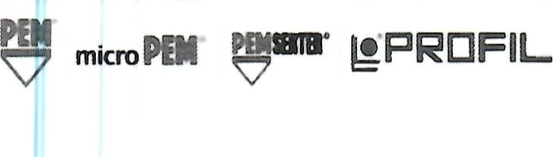5190 Old Easton Road

ALAS Danboro, PA 18916 USA

Tel: 215-766-8853 Fax. 215-766-0143 www.pemnet.com

January, 2025

Re: PFAS Compliance

Customers,

**This is PennEngineering's official confirmation that our company's products are completely free from Per- and Poly-fluoroalkyl Substances (PFAS). As a responsible and environmentally conscious organization, we understand the growing concerns regarding the presence of PFAS in various consumer products**.

**To this end (updated 1/2025)**:

*We can state that our standard product is PFAS free with the exception of our*[*PEM Blu-Coat™*](https://www.pemnet.com/wp-content/uploads/sites/2/2022/06/Blu-Coat.pdf)*thread mask and our [Sherex Disk Lock](https://fasteners.sherex.com/category/disc-lock-wedge-locking-washers" \o "https://fasteners.sherex.com/category/disc-lock-wedge-locking-washers).*

At PennEngineering, we prioritize product safety and compliance with relevant regulations and industry standards. PFAS, a group of man-made chemicals commonly found in numerous industrial and consumer applications, has raised significant health and environmental concerns due to its persistence and potential adverse effects.

We understand that the presence of PFAS is a significant concern for consumers, and we share your commitment to protecting human health and the environment. If you require any additional information or have specific inquiries regarding our products or processes, please do not hesitate to contact us. We are more than happy to address any concerns you may have.

Thank you for your trust and continued partnership. We remain dedicated to providing high quality, PFAS-free products that meet and exceed our customers' expectations

Rocky

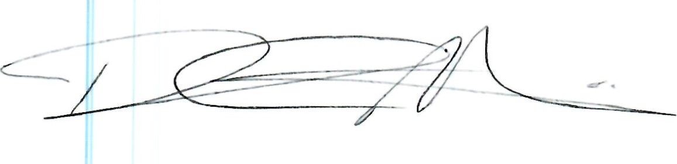

Rocky Pinheiro, Ph.D.

Global Vice President of Quality, PennEngineering

rpinheiro@pemnet.com 586-610-3500

